|  |  |
| --- | --- |
| 2018-2019 | Delano Adult School  High School Equivalency Course Frequently Asked Questions  You are never too old to set another goal or to dream a new dream. --C. S. Lewis |

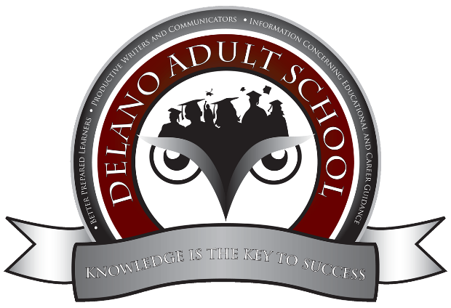

**Frequently Asked Questions and Answers**

**Question: Why should I obtain a High School Equivalency Certificate?**

Most employers require a high school diploma or a high school equivalency certificate. Also, these requirements pertain to entering college or the military. Finally, for immigrant students, the HSE Certificate is the only option to continue their education. And, for those who did not complete many units of high school, the HSE Certificate is the best option.

**Question: What is the difference between a GED Certificate and a HSE Certificate?**

The GED (general education development) is obsolete. It used to be a basic certificate based on approximately grade 8. Some employers of entry level positions accepted it whereas many employers did not, colleges did not, and the military did not. In 2014, when the change occurred from state standards to federal standards, the GED Certificate was no longer accepted. GED then became a company to offer curriculum and tests to earn a High School Equivalency Certificate. As the name states, the HSE Certificate is equal to a high school diploma. There are three companies now that possess accreditation for curriculum and testing to obtain the HSE Certificate: GED, HiSET, and TASC. After much research, the Delano Adult School has decided that the HiSET curriculum offer students the best opportunity to obtain their HSE Certificate.

<https://www.mometrix.com/blog/hiset-gaining-in-popularity-vs-the-ged/>

[**https://proliteracy.org/Blogs/Article/134/5-Frequently-Asked-Questions-About-GED-HiSET-and-TASC**](https://proliteracy.org/Blogs/Article/134/5-Frequently-Asked-Questions-About-GED-HiSET-and-TASC)

**Question: How long does it take to obtain the HSE Certificate?**

The average time required to study and pass all tests at the Delano Adult School has been eight months. Some students have passed in as few as two months whereas others have needed a full year. Determining factors include the following:

1. How many days will the student attend class each week?
2. Does the student own a computer and have internet service at home?
3. What is the educational level of the student upon entering the class?

**Question: What should I do as a new student?**

New students will first meet with the instructor so that they feel comfortable in the class. The teacher will provide information about the class, give the new student his/her first computer program, schoology.com, and introduce the new student to the class. The first week should be devoted to the following:

* Become familiar with the many resources on Schoology and how to message the teacher to report an absence.
* Become familiar with class policies.
* Become familiar with the HiSET curriculum so that the student can make the following decisions:
  + I am able to study another subject besides the current subject of the class because I have a high academic level in (reading, writing, mathematics, social studies, or science).
  + I have not been in school for a long time, so I need to study the current subject of the class to be able to understand the lessons being taught in class on the current subject.

**Question: What should I do if the class seems too difficult for me?**

Do not give up! Study hard! The Delano Adult School offers the following resources:

* Computer programs with instruction in all subjects, including videos.
* Group work where students help each other.
* Personal one-on-one time with the teacher.
* Bakersfield College tutoring.

**Question: Do all students have the same academic level in the class?**

No, not at all. Typically, there are several academic levels in each class (low, average, and high). Also, since the Delano Adult School has open enrollment, each class will always have students who have been in the class for varying lengths, so some students will already have passed tests whereas others have not. Our class works as a team, so students are constantly working in groups with other students to discuss and analyze questions and to receive help.

**Question: May I take an official test whenever I want or am I limited to following the class schedule?**

Our class is very practical, so students may schedule and take an official test whenever they want. However, this decision should be taken very seriously.

1. During the first part of class, during independent study (and of course during home study), advanced students should study the curriculum of a subject that they have already have mastered. This can be done via the official HiSET textbook, Aztec Portal computer program, Schoology folder with internet links and documents and a mini-practice test.
2. When ready, a student may take a practice test at any time with or without the teacher (Aztec Portal or HiSET textbook). If the student earns 60% or higher on a practice test, he or she should take the official test (this requires an account from HiSET.org) here at the DAS Testing Center. For advanced students, the teacher may serve more as a guide or private tutor. **However, generally speaking, for most students, it is best to follow the unit design of the teacher and follow each lesson and then at the end of the unit take the practice test with the rest of the class and the teacher under official test conditions.**

**Question: What if I need to leave school for a short time?**

Students can leave the Delano Adult School and simply register again during the following quarter. This does happen with many students due to the need to work or for personal reasons.